Lab Assignment-10

ECSE365L: Agile Software Development

**Name:** Tanvi Penumudy

**Enroll no**: E18CSE187

**Batch:** EB02

**Issue Types in JIRA**

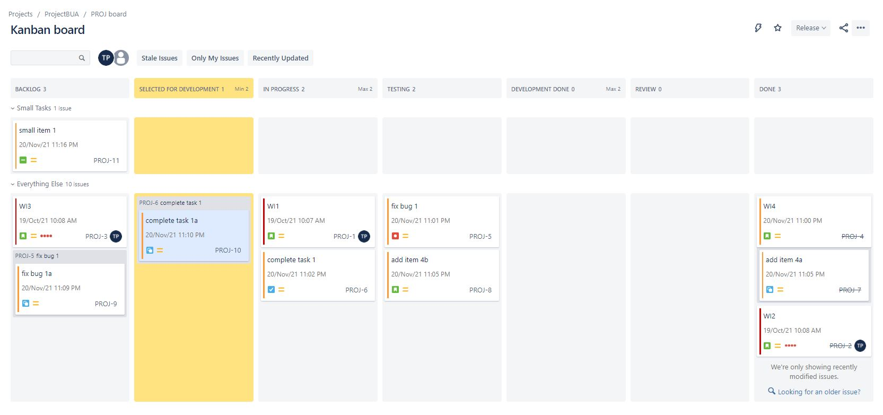

ssss